In this report I will be examining the different formats of British news. Although news format such as TV and radio are important, for this report I will be closely examining the role of the news through platforms such as print (magazines and newspapers) as well as examining online industries (social media, apps, online websites). The purpose and role of news is to inform and make people aware of current events. I will focus on the different formats of news, highlighting how print and online sources use platforms and what their style and content is. I will also mention a variety of news from national, local, regional and international news. Furthermore, I will discuss news practises such as news values, gatekeeping and editorial decisions plus sourcing and verifying materials. I will evaluate the code of practise and legal and ethical issues within print and online publications. Throughout this report I will give detailed examples of several news organisations and examine their publications.

FORMATS OF NEWS

PRINT:
Print is a physical form of news such as newspapers and magazines that have been distributed to several places for different purposes. For example the Peterborough Telegraph will only go to those who live in Peterborough. Whereas newspapers such as The Daily Mail are found on more of a national scale in terms of distribution.
The role of tabloid newspapers is to entertain by revealing news on topics such as celebrity gossip, scandals as well as being known for their inappropriate page 3 models. I have gathered three examples (The Sun, The Mirror and the Daily Express) formatted as tabloids. All three have similar colour schemes using red to promote the scandalous affairs as well as including several large images and large headlines so it doesn’t have the typical ‘boring’ newspaper feel. This appeals to the target audience of working and lower class common people roughly aged 15-45 with the usage of informal language within their articles and basic style that is easily readable for those in these lower social groups. The National Readership Survey claimed that within the last year (N.D) The Sun has been the leader of the market selling on average 7,860,000 a day whereas its closest contender, the Daily Mail only sells 4,846,000 a day on average. In the news, 2009. Target audience facts. [Online] Available at <https://flashnewsuk.wordpress.com/2009/10 /27/target-audience-facts/> [accessed on 21/11/2017.]
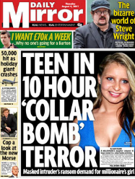
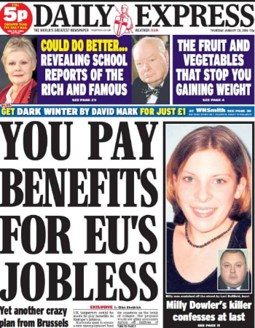
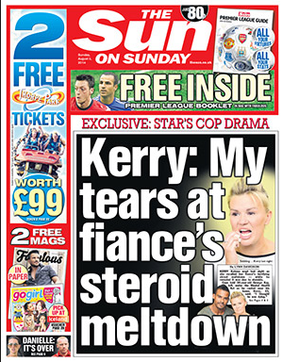

August 2011 - The Mirror
January, 2016 - The Daily Express

The Sun – old newspaper front page

The role of broadsheet newspapers is to inform and publish political and financial types of news and includes stories regarding subjects like the royal family. Broadsheet newspapers aim towards attracting middle and upper class groups aged around 25 and above. The layout of these newspapers is formal using technical language, avoiding slang and inappropriateness. I have chosen three examples of The Times, The Guardian and Independent. All three front covers show more text than the tabloids as well as covering hard news stories rather than soft news stories. Although each broadsheet newspaper includes at least one image it’s rare to find any more than that as they want to give a professional feel to meet the needs of their target audiences to give more information.

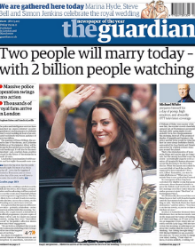
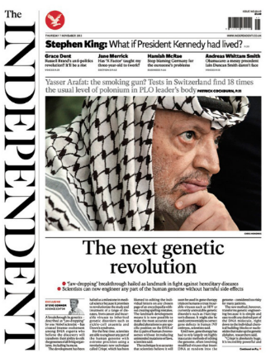
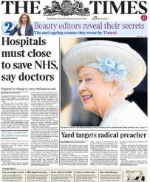

The Independent – old newspaper

June, 2013 - The Times

2014 - The Guardian

Magazines have a niche appeal to their subject specific articles for example you wouldn’t find a music magazine talking about makeup. This creates smaller target audiences which varies depending on what the topics are about.

ONLINE:
“We’re all online journalists now.” – Paul Bradshaw and Lisa Rohumaa, 2011. The Online Journalism Handbook
Websites:
Looking closely at online news websites I will examine their ways of getting their news spread. I have examined The Sun online (tabloid) as well as The Guardian online (Broadsheet).
Interaction with the user and The Sun by being able to create an account to create a loyal rapport
Several categories exploring different types of news. This is beneficial for their target audience as the headlines are linked with issues they’ll be interested in
Being able to search makes finding stories quick and easy. This is helpful for their target audience as they’ll be busy at work / school and this is a time saving method

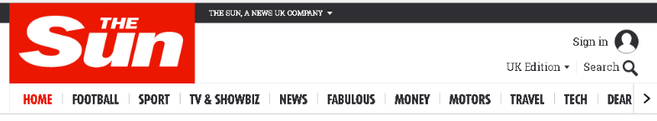
The Sun 24/11/2017

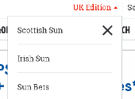
TV & SHOWBIZ appeals to working and lower class people who are interested in celebrities rather than hard news

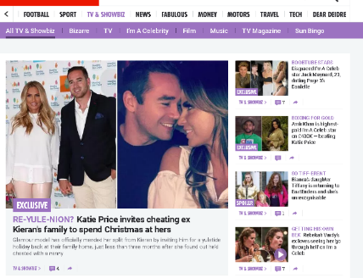
This allows people access The Sun online from no matter where they live around the UK
These sub stories also explore celebrity gossip. Most sub stories online don’t tend to be found in the newspapers which implies it’s an online exclusive

In comparison to The Sun, The Guardian has been organised in a professional way to appeal to their target audience of the upper classes. As seen below, The Guardian discusses hard news issues such as Brexit where as The Sun focus heavily on soft celebrity news.

‘Become a supporter’ - Allows audiences to feel involved. This is beneficial for the elder aspect of their target audience for them to feel like they have a purpose and something to be a part of
Creating an account creates a strong rapport between reader and The Guardian

Additional features on the site shows the Guardian offering more than just news
The Guardian 24/11/2017

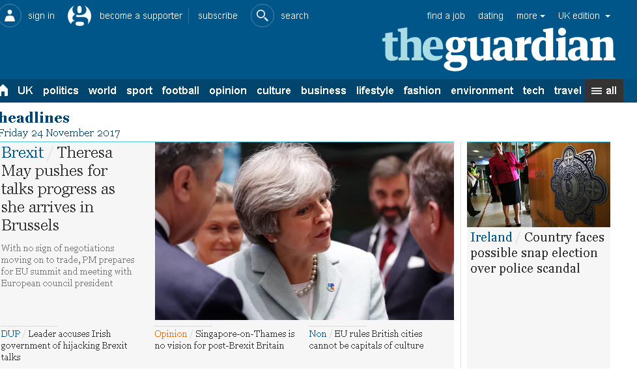

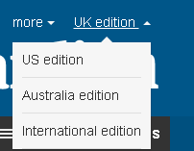
There is more than one edition which shows their influence over news and knowledge of international interactions

Categories
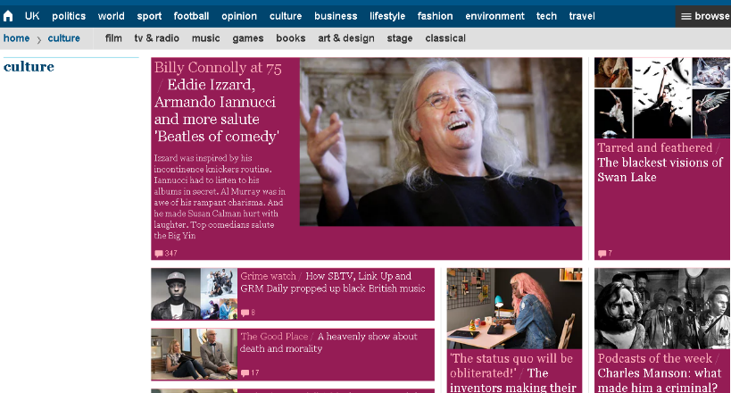
The Guardian 24/11/2017

The search options makes searching for news easier

The Guardian 24/11/2017

There is a page for each category
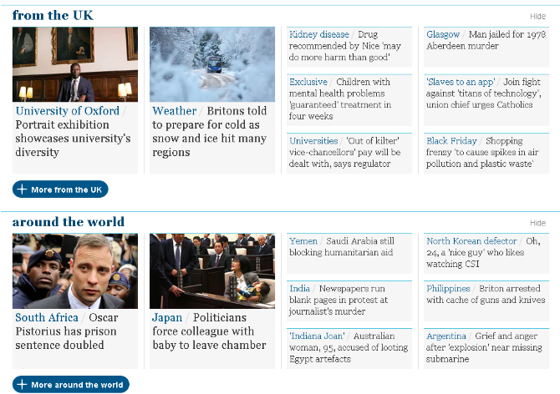

Various culture stories on music, TV and announcements which shows an upper class culture of arts that will appeal to their target audience rather than the bottom classes who suffer from a lack of income and can’t indulge in the arts

Gives a chance to see what’s happening worldwide as well as within the UK

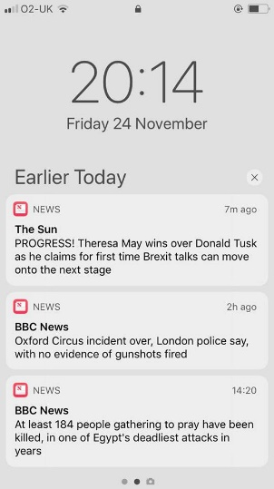
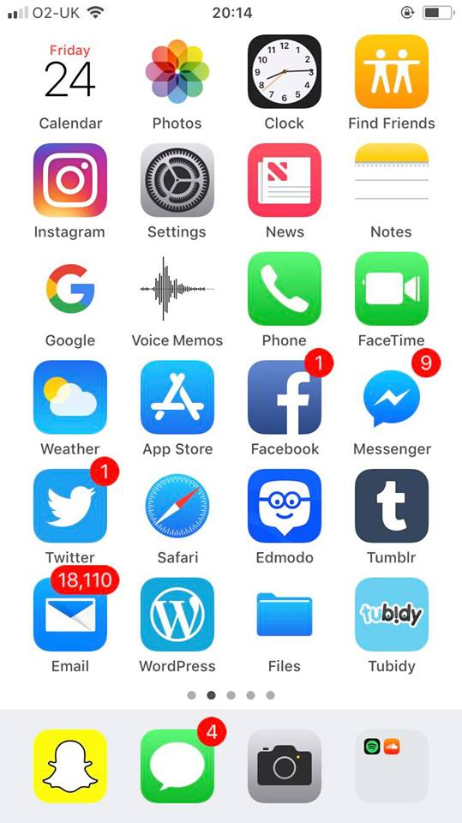
Apps:
News app (IPHONE)
There’s a variety of different news organisations mentioned on the app to fulfil all types of needs for news
By signing up to notifications I receive daily updates of news stories without having to check the app itself which saves time and allows me to see the stories straight away

Social media:
Social media is an increasingly popular platform when uncovering news stories as it’s a 24 hour platform of news which is interactive and un-censored. Through the hashtag (#) news can be widespread worldwide whether or not you’re a qualified journalist. It’s more common for the younger generations to interact through social media therefore these industries will aim their stories at teenagers and young adults. It’s becoming growingly easier to interact on social media through advances such as comment sections, hashtags and private messaging.



SNAPCHAT
Snapchats discovery page shows various trending stories which turn into a click slideshow about the organisations picks of what’s news worthy and relevant to publish on that day

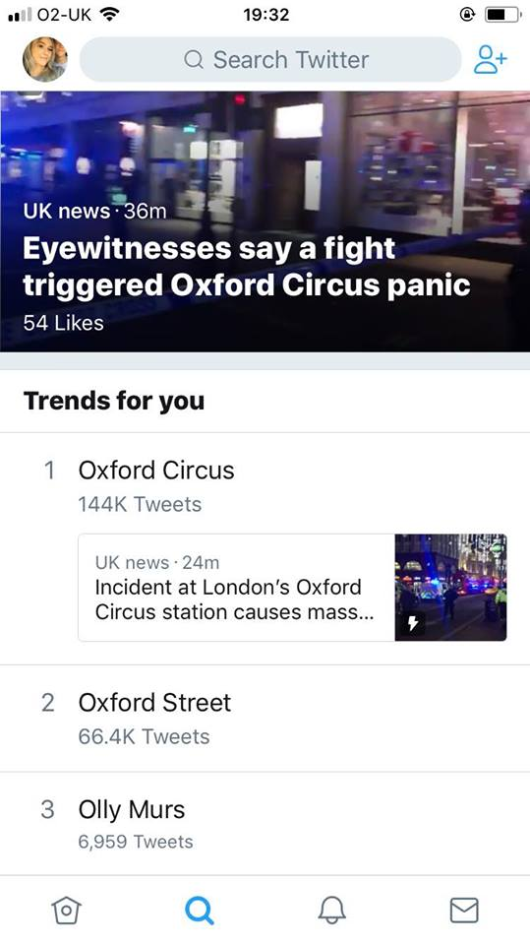
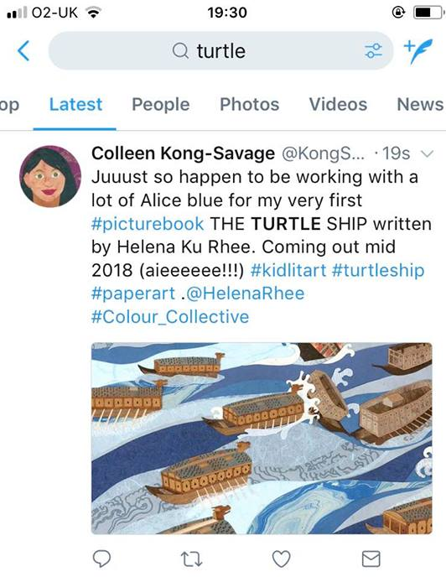
If you search a subject at the top you’ll get redirected to feeds about the searched topic. By clicking on ‘latest’ you’ll see the most recent tweets.

TWITTER

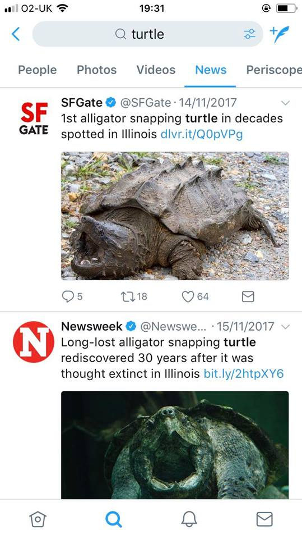

Twitter gets personal when it comes to news as it provides ‘trends for you’ so you’re able to see what news stories are happening that is relevant to topics you’ve previously shown an interest in
Once searching, you can also click on the ‘news’ category which directs you to a feed full of news stories on chosen subject by the official twitter pages of news companies (as seen by blue tick)

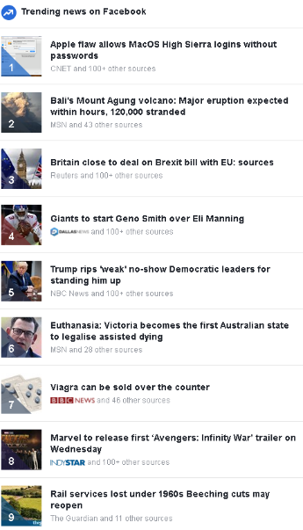
Trending news on Facebook provides 20 of the top trending stories which allows people to discover the newest news stories

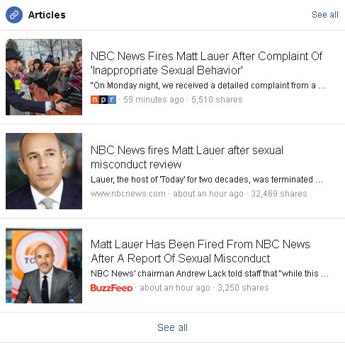
FACEBOOK

Facebook also provides links to news articles. If you click on a story you’ll be directed to the source of information showing accurate news which helps promote the news organisations’ websites


NEWS TYPES
Regional news: My local town is Huntingdon and it’s in the region of Cambridgeshire meaning that the ‘Cambridge Evening News’ paper is my regional newspaper. The stories target people from the specific region to spread awareness of news events happening in local towns/ cities. For example the main story given is relevant to the toymakers of Cambridge being hated by bomb victims.

Cambridge Evening News - Sep 2006

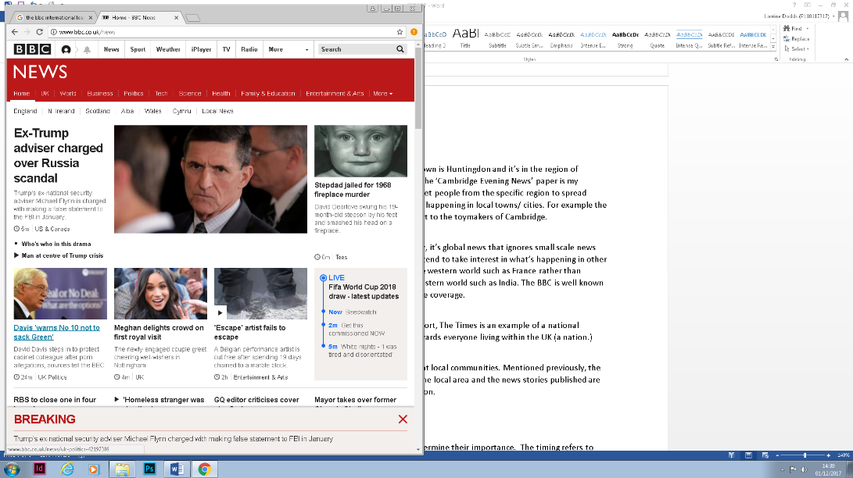
International news: Simply, it’s global news that ignores small scale news stories. Within the UK we tend to take interest in what’s happening in other countries from the western world such as France rather than countries in the eastern world such as India. The BBC is well known for their worldwide coverage as shown by their online home page showing an article about America’s president Donald Trump’s adviser being charged over Russia scandal.
BBC News website – 01/12/2017

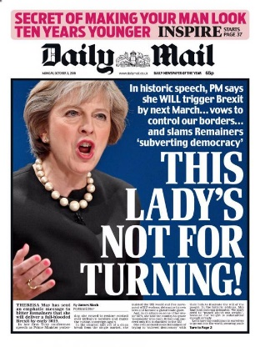
National news: As previously mentioned in this report, The Daily Mail is an example of a national newspaper. National news targets their stories towards everyone living within the UK (a nation) with issues concerning anything about the UK in general. As seen by this front cover it has focused on the PM of England, Theresa May.

Daily Mail - Oct 2016


Local newspapers: Aim their news almost entirely at local communities. Mentioned previously, the Peterborough Telegraph is aimed at those within the local area and the news stories published are based on the proximity of the story from the location. For example, this front page’s lead story is about a notorious criminal making Peterborough his home.

Peterborough Telegraph – Jan 2015


NEWS PRACTISE
News values consist of guidelines for stories to determine their importance. The timing refers to when news should be reported such as breaking news being reported instantly to warn people of news such as terror attacks. Furthermore, some newspapers use continuity to repeat on going stories, and example of this is The Daily Mirror repeating stories about Madeleine McCann.
(Irish) Daily Mirror – Apr 2014

Gatekeeping is where editors make decisions of what is publish worthy which is influenced by the elite nations or the people. The BBC News focuses on Theresa May and issues concerning Brexit as it’s relevant to their target audience (older generations and social classes of A, B, C1) whereas The Sun focuses on celebrity news (youth interests within social classes of C2, D, and E.)
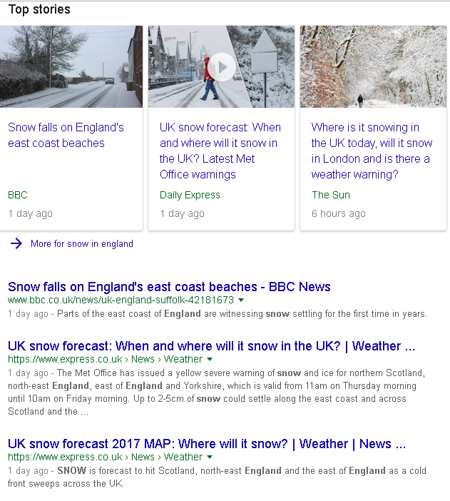
Editorial decisions can be swayed by search engine optimisation (SEO) which is how we are able to find what we are looking for in the fastest way possible. This is vital for online journalists, once they’ve found out the most searched key terms and phrases they’ll use them within their headlines, URL and page title to make their site will be commonly looked at. Search terms are also used so that a site has the opportunity to see what terms are commonly searched through search engines such as Google, Bing and Yahoo. A way that sites attract more traffic through means of SEO is by updating the site regularly which allows their site to go to the top of the search engine. Web traffic shows the number of visitors who go onto a site and how many pages they choose to visit. Specifically, news websites will use this to see what the best and worst pages of their site to make improvements. Another way news sites determine the success of their website is they can look at the bounce rate to see what percentage of people leave the site without looking at more than one page.
After searching “snow in England” on Google several recent stories came up and it’s clear to see that the BBC have been recently publishing stories on the weather as well as the express. (01/12/2017)

SOURCING AND VERIFYING MATERIALS

Good taste within journalism is an ethically considered method. Journalists need to think about several aspects before publishing a story. For example, it must use clean language and not be explicit in anyway as well as considering the images added (cautious of adding images of dead/ ill people which may put readers off.) An example of bad taste is the image used by the Daily Mirror of a screenshot of a woman about to be shot and killed from a publically shared video. (Aug, 2015)
Objectivity concerns journalists as they’re not allowed to voice their opinions or biases in their stories, especially when discussing hard news. This is easily avoided by using neutral language and having no characterisations of organisations or people whether it’s good or bad.
The IPSO (Independent Press Standards Organisation) editors code of practice lists several rules to be followed. The main ones are; accuracy, privacy, harassment, correctly reporting suicide, children cases, discrimination and confidential sources. IPSO, 2016. Editors’ code of practise. [Online] Available at: <https://www.ipso.co.uk/editors-code-of-practice/> [accessed on 22/11/2017] code of practise. Additionally, a reporter cannot trespass on property and needs permission to take images without harassing the subject. Privacy is a key aspect which reporters tend to not acknowledge. In order to stick to these rules and remain legally and ethically moral a reporter must obtain their evidence from reliable sources who have relation to the chosen topic.
A main legal issue is the concern of children in news. Legally, if they’re under the age of 18 you’ll need consent from their guardian to be allowed to talk and take images of the child as well as having to keep their identity anonymous (but there is an appeal which goes against this.) Whereas when speaking about adults it’s an ethical concern involving anonymity. If someone has asked to be protected and kept anonymous it must be respected. Similarly, confidentiality is another ethical difficulty that needs to be considered as personal issues should be kept private if the subject has made a request.
The reporter’s reputation heavily depends on the accuracy of what they’ve written because the source needs to be able to make a rapport with the reporter. If false information has been leaked it could ruin an innocent person’s life and can also lead to personal/ business suing and a risk of getting fired or imprisoned with any reputation being ruined. Reporters need to know the difference between conjecture (opinions) and facts.
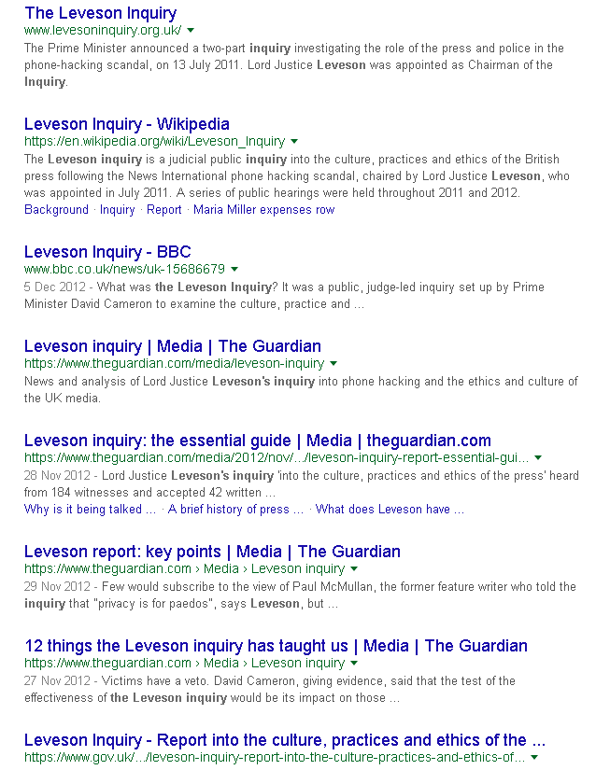
An example of misuse of ethical and legal issues can be shown through the Leveson inquiry linking to the culture, practises and ethics of the British press, chaired by Lord Justice Leveson. The story broke in 2005 with information about phone hacking scandals that had been taking place. This led to public hearings happening within the years of 2011 and 2012. Furthermore, there were large masses of news stories that broke the web. By searing on the search engine of Google there’s plenty of stories about this case showing what a wide spread scandalous news story it was.
The BBC website covered the recommendations which followed the scandal. Firstly, newspapers should be self-regulated with government having no power on what to publish. Secondly, the bodies should be backed by legislation to keep an eye on the practises of news. Thirdly, there had to be new press standard body creating a new code of conduct through the industry. Overall these recommendations were thought to have provided the public with confidence that their complaints would be taken seriously and dealt with in a way that meets their future concerns.
Google search for ‘Leveson Inquiry’ 2017

WORD COUNT: 2,520
(NOT INCLUDING REFERENCE LIST)

REFERENCE LIST
BBC, 2012. Press ‘need to’ act after Leverson. [Online] Available at <http://www.bbc.co.uk/news/uk-15686679> [accessed on 24/11/2017]
In the news, 2009. Target audience facts. [Online] Available at <https://flashnewsuk.wordpress.com/2009/10/27/target-audience-facts/> [accessed on 21/11/2017]
“We’re all online journalists now.” – Paul Bradshaw and Lisa Rohumaa, 2011. The Online Journalism Handbook

BIBLIOGRAPHY
The National Archives. 2014. LEVESON INQUIRY: CULTURE, PRACTICE AND ETHICS OF THE PRESS. [Online]. Available at <http://webarchive.nationalarchives.gov.uk/20140122144906/http://www.levesoninquiry.org.uk/> [Accessed on 27/11/2017]

Chris, A. What Is Search Engine Optimization And Why Is It Important. [Online]. Available at <https://www.reliablesoft.net/what-is-search-engine-optimization-and-why-is-it-important/> [Accessed on 16/11/2017]

Parfinovica J, 2017. Why 0% Bounce Rate Is not Good News!. [Online]. Available at <https://www.togetherdigital.ie/blog/why-0-bounce-rate-is-not-good-news> [Accessed on 21/11/2017]

Big Commerce. What is Website Traffic and how to interpret it. [Online]. Available at <https://www.bigcommerce.co.uk/ecommerce-answers/what-is-website-traffic-and-how-to-interpret-it/> [Accessed on 25/11/2017]

Robrish, D., 2015. What are the main differences between local newspapers and international ones. [Online] Available at <https://www.quora.com/What-are-the-main-differences-between-local-newspapers-and-international-ones> [Accessed on 29/11/2017]

